Tymoteusz Jerzy Masiakowski
3rd Year Photographic and Electronic Media
Student number: 0709560

Technology as a bringer of possibilities – does technology change artistic practice?

Wordcount: 2542.

Technology is everything these days. It augments, enables and enhances the world around us. It also reduces whatever difficulties we may encounter and is supposed to improve the general quality of life. We entrust machines with various tasks that range from speeding up our daily routines through self-education to performing groundbreaking scientific research. Advanced technology entered nearly every possible field of expertise and thus our whole existence relies on the machines we create.
As a consequence, what we live in is not a pure reality anymore, as we perceived it in the past, but a mixed techno-reality full of fascinating data that is yet to be discovered but is already gone. Before we even find it, it becomes buried under another, fresh wave of information. Relying on a machine requires from a human being to be able to keep up with its pace, otherwise one can become confused and disorientated.
More than 10 years ago Erik Davis wrote a statement which is still perfectly valid as it describes the world in its current status: ‘Boundaries dissolve, and we drift into the no-man’s zones between synthetic and organic life, between actual and virtual environments, between local communities and global flows of goods, information, labour and capital’. And in this world it is a necessity for us filmmakers and videographers to adapt to and enjoy the new possibilities it gives us.
This essay concentrates on the influence of technology on the arts and discusses whether the extensive technological progress changes the way in which we produce and perceive the production of art.
First step in a journey of the analysis of the connection between technology and art is to look at the language and meaning. Word technology consists of two parts: techno- and –logy both of which originate in Greek as techne and logia. On one hand, Techne is a word that directly translated means ‘craftsmanship, craft or art (…) a rational method involved in producing an object or accomplishing a goal or objective (…) through art’; other sources list translation of techne as ‘skill’, which is more accurate in my opinion. On the other hand -logia is explained as ‘a suffix denoting the study of something, or the branch of knowledge of a discipline’.
So technology as a word can be thought of as the study of a skill, which brings us back to the topic of an artist. On the level of meaning technology deals with skills and so does art. Every artist has a set of skills that is needed to pursue a particular field interest, which means that the core of art is a skill itself. Artist, in order to create has to have a particular set of those to accomplish it. Without a necessary skill, an artist would have a problem to create the artwork.
In our technology-driven world we surround ourselves with tools that enhance the skills, act as an artificial, virtual arm that aids us in various endeavours. Any invention could be described as a tool by means of which we are able to create something new. Interestingly, Longman Dictionary of Contemporary English defines technology as ‘new machine, equipment, and way of doing things that are based on modern knowledge about science and computers’. This ‘way of doing things’ is important for us as artists as we progress with the themes of practice.
As an additional skill enhancer, technology is priceless as it enables us to conceive things like never before. When a new ‘way of things’ is invented, it either creates a simplified way or it forces us to adjust by acquiring a completely new skill. Both options are worth it since they are expanding horizons of imagination in the same field: the field of a skill. Simplification creates a faster workflow and learning a new skill is a worthwhile activity, full of opportunities.
A good example to illustrate ‘new way of doing things’ would be the newly created discipline of DSLR filmmaking, which has recently sprung to attention. There is in fact a silent but widespread revolution going on for some time now in the world of video recording technology. It is based on the use of hybrid digital cameras capable of taking high-resolution photographs and more importantly High Definition video.
Filmmakers and videographers switch from standard video cameras to DSLR photo-video hybrids like Canon 5D Mark 2 or Nikon D90. Experts such as Vincent La Floret and Philip Bloom already made or are making their way to the market with detailed tutorials for DSLR filmmaking. For the argument’s sake I will concentrate only on Canon 5D Mark 2 hybrid camera model since it is the one I currently posses and use in my practice.
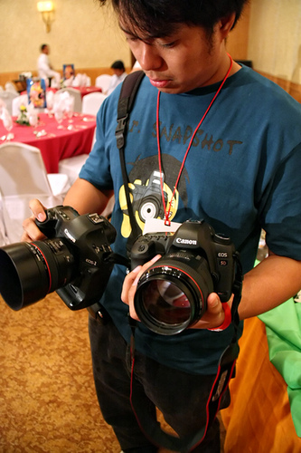
It is interesting that I observed among artists that on the one hand photographers who use such hybrid cameras start using its video mode more often to get a different perspective on their work and on the other hand filmmakers start taking photographs to aid their video material. It is clear that crossing and extending into other media is beneficial for artists. It helps with documenting and gaining a totally different view on your work.
As one of the chapter titles of a book written by Erik Davis states „the path is a network“ it is safe to say that technology created a shift in craftsmanship from a singular „learning road“ towards a vast cross-disciplinary realm. Once it is entered we need to acquire a new skill.
Image 1.
As I said, I use such a hybrid camera in my studio practice and from personal experience I admit it is an incredible tool for both filmmakers and photographers and any other type of an artist. It has several advantages over traditional video recording equipment:
First of all, it is its mobility. One can go to previously unreachable places without exerting much effort to move the equipment, which is exactly what Greg Yaitanes, director of TV series entitled House, said in a Twitter interview when asked about shooting the whole final season of the series on Canon 5D Mark 2: ‘wanted it for the ease of use in tight spaces’. As one can see in Image 1, DSLR camera is significantly smaller and lighter than traditional video cameras, which saves effort, time and money to organize everything on a film set. Due to its small size it can be used for journalism, especially field journalism where timing and transportation is an issue of importance; other uses of such technology include scientific documentation due to its high quality image.
Hybrid cameras also have been used in an almost infinite number of feature and short films around the world, which brings us to such attributes as flexibility, accessibility and quality. Filmmaking in the past used to be a difficult, expensive business but thanks to such invention as DSLR filmmaking it is all changing. Now both independent filmmakers and film companies will be able to take advantage of using capable and consumer-style-but-state-of-the-art equipment.
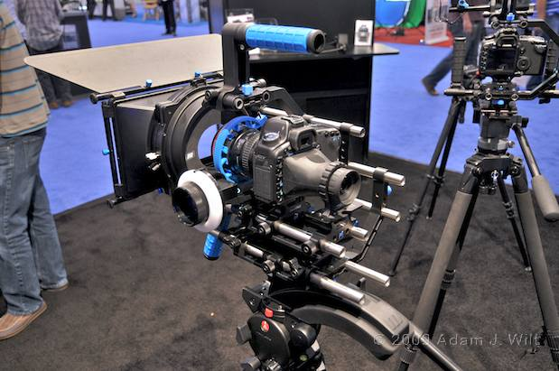
Flexibility: There is a whole range of DSLR filmmaking gear that one can add to increase the functionality. Small-time filmmakers and professional ones can customize hybrid cameras to their liking, adding as much as they need.
Image 2. Canon 5D Mark 2 in a Red Rock Micro rig.

From a simple DSLR camera one could create a large rig containing stabilizers, matte boxes, external monitors, audio recording equipment and much more. Or it could be used as a simple documentation device on its own. Image 2 presents an example of a larger rig.
Accessibility: Canon 5D Mark 2 is considered to be a semi-professional camera. From observation and personal experience it is cheaper than professional cameras and it delivers a lot better performance. However the most important fact is that more people will be able now to obtain high-end visual results.
Quality: Reportedly ‘a top commercial film editor who regularly edits RED camera footage - and has seen the raw footage from the 5D MKII - says the 5D MKII is far superior to the RED camera in terms of low light performance’.
Both accessibility and quality factors create a demand for a filmmaker or a journalist for a better story. There is no excuse for the visual side if one has easy access to quality equipment like DSLR cameras shooting high quality video.
From one point of view DSLR filmmaking and hybrid cameras are a groundbreaking technology, which created vast new possibilities for artists of all fields. They definitely change the way we produce films and all sorts of visual motion material. They simply redefine the way a filmmaker works by giving him a better technological back up. Thanks to that that artworks created within this field become a niche on its own as they are all unique.
However, from another point of view one could ask ‘why are we investing into technology like that?’. It obviously gives us advantages but it also creates another complex system we have to learn by heart to be able to efficiently use it. It is another gadget layer in the production of art. The answer to the question could be that we, both as an audience and an artist strive for quality and easiness of access and production at the very same time. And that is what did not change in the artist’s practice along with the technological progress.
Technological complexity is opposed by the simplicity - getting rid of unnecessary or problematic elements in the equation. There seems to be a trend to simplify technology as it becomes more advanced. Due to that we become immersed in a virtual world and we often merge it with the real world around us as we lose the physical side to technological interaction.
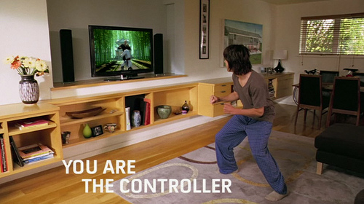
An example of that could be Project Natal, developed by Microsoft. It is basically a controller-free environment for Xbox 360 console, which enables you to project your every body movement into the virtual game world. You can control and react to the virtual world as if you were there, it will respond to your every change in position and action. You can see an example of how it will look on Image 3 below.
Image 3. Project Natal.

This technology is already here as Project Natal is going to be released some time in December 2010. Steven Spielberg being a supporter of interactive entertainment said that ‘the only way to bring it to everybody is to make the technology invisible’. He also describes it as a ‘technology that not only recognizes your thumbs and your wrists but your entire being’. I agree with that with the context of producing art in mind. Once we make the technology invisible it will enable us to create new ways of artistic expression. It opens a multitude of possibilities beyond game entertainment. For instance if we apply such motion technology to animated film productions we could easily use actual real actors to perform as animated characters. Controlling the ‘content’ of such animation would become a symbiotic relationship between the actor and the visual output he or she produces. One could call it virtual acting.
Imagine if you could use that to edit live films or create artworks. It would be a revolution in the sense of production. Faster workflow as you’re using gestures on the go to trigger scripted actions within the application; enhanced overview, as you would be able to arrange and organize elements of the application in any way you want; greater control over the film footage as you sort through it; it is an incredible opportunity for filmmakers.
Project Natal technology sparks an interesting issue from the point of view of arts. As Reena Jana says ‘works of New Media art require audience members to interact with the work but not to participate in its production. Interactive New Media art responds to audience input but is not altered by it. Audience members may click on a screen to navigate through a web of linked pages or activate motion sensors that trigger computer programmes, but their actions leave no trace on the work itself. Each member of the audience experiences the piece differently based on the choices he or she makes while interacting with the work‘.
First of all, that is an exact description of what Project Natal does. Second of all, according to this quote production would be still the responsibility of the artist, the audience could be only the receiver of art, not the active participant.
Having all that in mind I disagree with the Reena Jana. New Media art will be open to audiences input soon enough. I also think that due to the recent technological developments we will be able to freely collaborate in one virtual space on any artistic project possible. In some cases we can already do that. Artist’s practice is changing.
Such technology is at hand but still in the testing phase. It is called G-Speak Spatial Operating Environment and is being developed by Oblong. In Image 4 you can see how it could change the way we produce art. Gesture-controlled video editing would be of great advantage for the editors. It supports multiple screens and enables the user to switch from one screen to another seamlessly dragging along content with a move of a finger. It would create make a great difference if it was to enter the professional market.
Image 4. G-Speak.

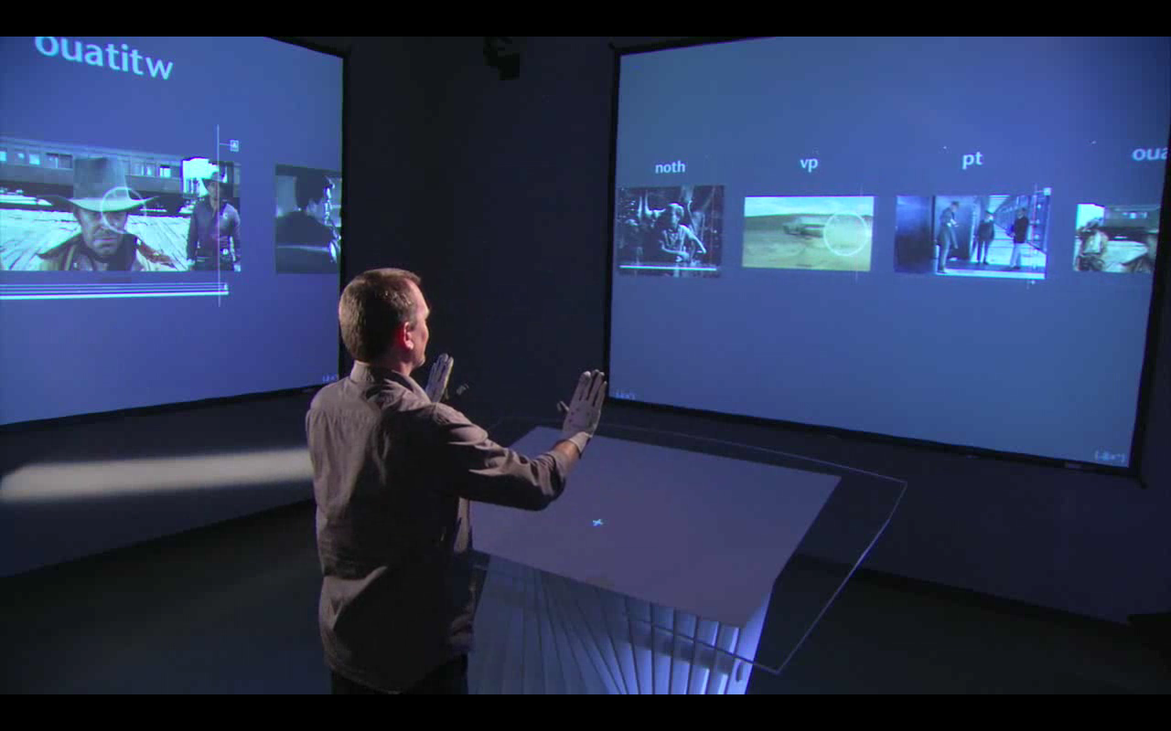
Speaking of such spatial environment one cannot withhold a feeling of absolute transformation of the artistic processes. We are already on the path to transformation of art production but full, working semi-virtual environment seems like something very distant and unreal. We are still not acquainted with the thought that something of such different approach could become a normal way to create.
Image 4. G-Speak.

Iain A. Boal in his essay A Flow Of Monsters: Luddism and Virtual Technologies was almost right when he said ‘More recent information technics – among them holography, xerography, satellites, videotape, videophones, and fiber optics – are currently said to have reached a critical mass such that profound societal transformation is imminent’. In my opinion this ‘transformation’ is not yet there but we are close to it.
It is perhaps only the beginning of things to come. Creation of new, or perhaps just evolved, artistic activities that are enabled to us by means of the evolution of tools we use. Summing up, all three examples of new disciplines/technologies: DSLR filmmaking, Project Natal and G-Speak Spatial Operating Environment prove that it is inevitable that the artist’s practice, the way we produce art, will change at some point in the future. It is always about the tools that are shaping our view on the reality. Technological progress enables us to enhance the reality around us through various manipulations of the visual layer of perception.
There is one more issue here: the better the quality of a new technology the more demand it creates for good content. And that’s what I am hoping for. Less attention put into the visual side and more significance put into the thought behind the artwork. Thanks to new technologies we can slowly start forgetting about the visual side, as it will become granted with some skill and passion - and concentrate on something far more important. On how technology and art transforms not our works alone but ourselves.
Bibliography
Brook, James; Boal, Iain, Resisting the Virtual Life: The Culture and Politics of Information, City Light Books 1995.
Davis, Erik, TechGnosis: myth, magic + mysticism in the age of information, Serpents Tail 1998.
Jana, Reena; Tribe, Mark, New Media Art, Taschen 2007.
Summers, Della, Longman Dictionary of Contemporary English, Pearson Education Limited 2003.

Websites
Dictionary.com Reference: http://dictionary.reference.com/browse/technology
G-Speak Overview (video): http://vimeo.com/2229299
Philip Bloom Website: http://philipbloom.co.uk/
Philip Bloom Article: http://philipbloom.co.uk/2010/04/10/house-season-finale-shot-entirely-with-canon-5dmkii/
Project Natal Official Website: http://www.xbox.com/en-us/live/projectnatal/
Steven Spielberg and Xbox Project Natal: http://www.youtube.com/watch?v=jh9plZmFIP4
Wikipedia: http://en.wikipedia.org/wiki/Techne
Wiktionary: http://en.wiktionary.org/wiki/-%CE%BB%CE%BF%CE%B3%CE%AF%CE%B1
Vincent La Floret Blog: http://blog.vincentlaforet.com/
Vincent La Floret Article: http://blog.vincentlaforet.com/2008/09/20/something-very-interesting-is-comingboth-to-this-blog-and-to-our-industry/

Illustrations
Image 1: Two Canons 5D Mark 2 in hands.
http://farm4.static.flickr.com/3156/2947630261_c49956e5a0.jpg
Image 2: Canon 5D Mark 2 with a camera rig.
http://provideocoalition.com/images/uploads/NAB0908-DSC_2552.jpg
Image 3: Project Natal.
http://www.flickr.com/photos/msblogspain/4496811719/
Image 4: Screenshot from G-Speak Overview video.
http://vimeo.com/2229299

Davis, Erik, TechGnosis: myth, magic + mysticism in the age of information, Serpents Tail 1998, p. 1.
Dictionary.com Reference: http://dictionary.reference.com/browse/technology
Wikipedia: http://en.wikipedia.org/wiki/Techne
Dictionary.com Reference: http://dictionary.reference.com/browse/techno-
Wiktionary: http://en.wiktionary.org/wiki/-%CE%BB%CE%BF%CE%B3%CE%AF%CE%B1
Summers, Della, Longman Dictionary of Contemporary English, Pearson Education Limited 2003, p. 1704.
Official Vincent La Floret Blog: http://blog.vincentlaforet.com/
Philip Bloom Website: http://philipbloom.co.uk/
Davis, Erik, TechGnosis: myth, magic + mysticism in the age of information, Serpents Tail 1998, p. 319.
http://philipbloom.co.uk/2010/04/10/house-season-finale-shot-entirely-with-canon-5dmkii/
http://blog.vincentlaforet.com/2008/09/20/something-very-interesting-is-comingboth-to-this-blog-and-to-our-industry/
Project Natal Official Website: http://www.xbox.com/en-us/live/projectnatal/
Steven Spielberg and Xbox Project Natal: http://www.youtube.com/watch?v=jh9plZmFIP4
Steven Spielberg and Xbox Project Natal: http://www.youtube.com/watch?v=jh9plZmFIP4
Jana, Reena; Tribe, Mark, New Media Art, Taschen 2007.
G-Speak Overview: http://vimeo.com/2229299
Brook, James; Boal, Iain, Resisting the Virtual Life: The Culture and Politics of Information, City Light Books 1995, p. 6.

